**Supplementary Tables and Figures**

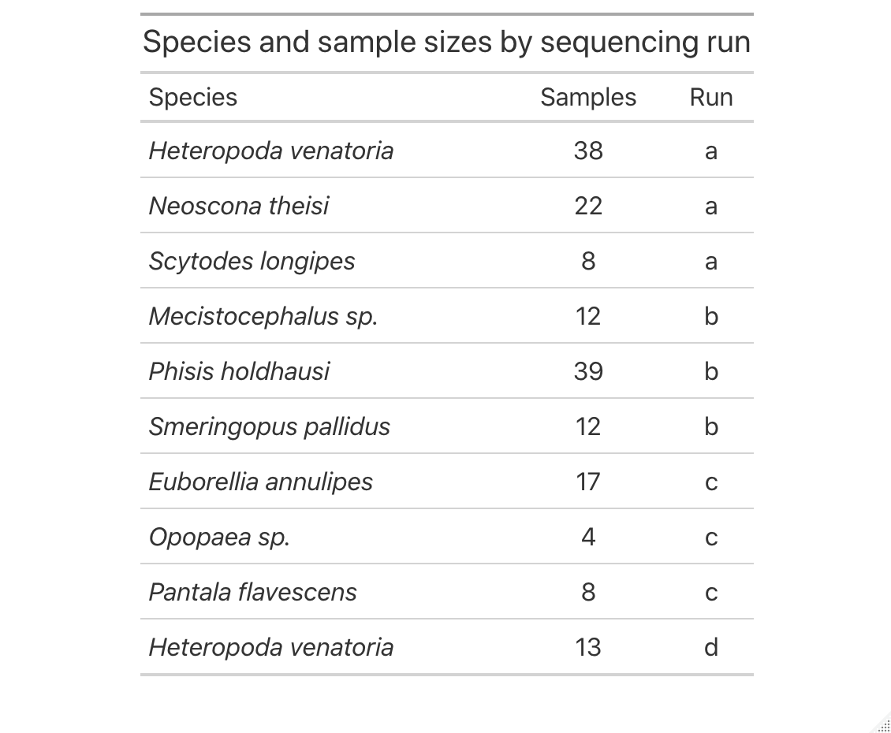

SI Table 1: Samples by species on each sequencing run

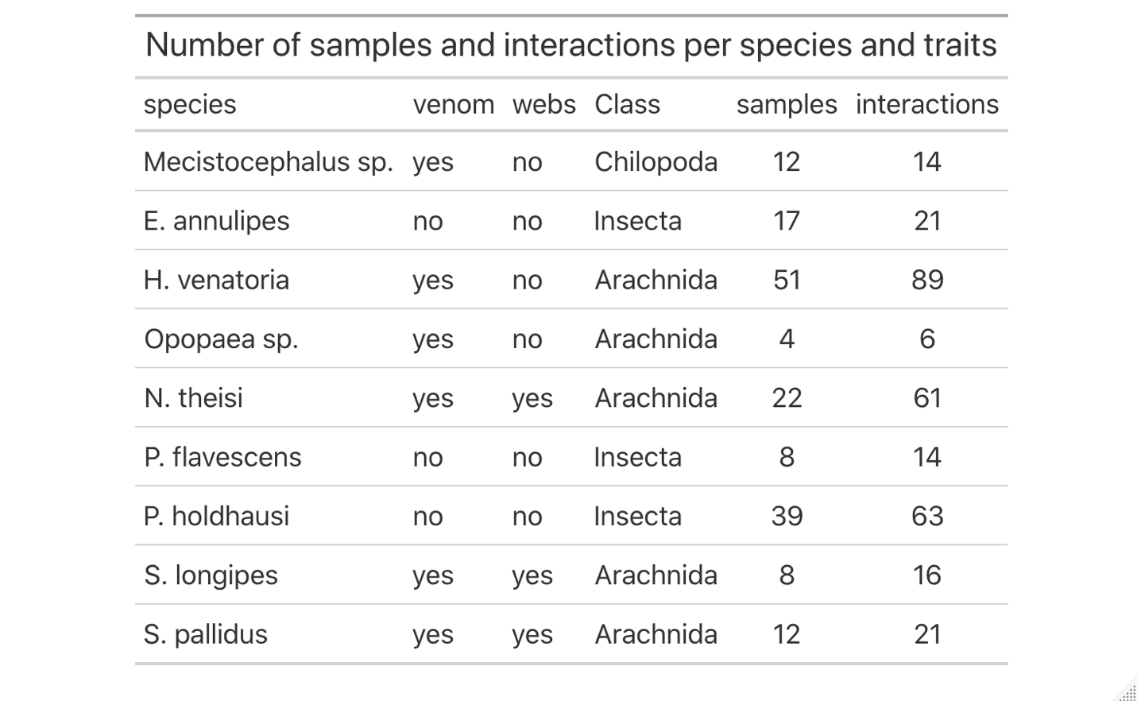

SI Table 2: Predator species, traits, sample sizes, and number of total interactions

|  |  |  |
| --- | --- | --- |
| **Class** | **Order** | **Family** |
| Arachnida | Araneae | Araneidae |
| Arachnida | Araneae | Oxyopidae |
| Arachnida | Araneae | Pholcidae |
| Arachnida | Araneae | Salticidae |
| Arachnida | Araneae | Theridiidae |
| Arachnida | Sarcoptiformes | Acaridae |
| Arachnida | Sarcoptiformes | Pyroglyphidae |
| Arachnida | Sarcoptiformes | Suidasiidae |
| Chilopoda | Geophilomorpha | Mecistocephalidae |
| Collembola | Entomobryomorpha | Entomobryidae |
| Collembola | Entomobryomorpha | Isotomidae |
| Insecta | Blattodea | Blaberidae |
| Insecta | Blattodea | Blattidae |
| Insecta | Blattodea | Ectobiidae |
| Insecta | Coleoptera | Coccinellidae |
| Insecta | Coleoptera | Curculionidae |
| Insecta | Coleoptera | Elateridae |
| Insecta | Coleoptera | Hydrophilidae |
| Insecta | Coleoptera | Staphylinidae |
| Insecta | Dermaptera | Anisolabididae |
| Insecta | Diptera | Agromyzidae |
| Insecta | Diptera | Cecidomyiidae |
| Insecta | Diptera | Ceratopogonidae |
| Insecta | Diptera | Chloropidae |
| Insecta | Diptera | Culicidae |
| Insecta | Diptera | Dolichopodidae |
| Insecta | Diptera | Limoniidae |
| Insecta | Diptera | Lonchaeidae |
| Insecta | Diptera | Phoridae |
| Insecta | Diptera | Platystomatidae |
| Insecta | Diptera | Sciaridae |
| Insecta | Diptera | Stratiomyidae |
| Insecta | Hemiptera | Aleyrodidae |
| Insecta | Hemiptera | Coccidae |
| Insecta | Hymenoptera | Eulophidae |
| Insecta | Hymenoptera | Evaniidae |
| Insecta | Hymenoptera | Formicidae |
| Insecta | Lepidoptera | Agonoxenidae |
| Insecta | Lepidoptera | Crambidae |
| Insecta | Lepidoptera | Erebidae |
| Insecta | Lepidoptera | Tineidae |
| Insecta | Odonata | Libellulidae |
| Insecta | Orthoptera | Acrididae |
| Insecta | Orthoptera | Mogoplistidae |
| Insecta | Orthoptera | Tettigoniidae |
| Insecta | Psocoptera | Ectopsocidae |
| Insecta | Psocoptera | Lepidopsocidae |
| Insecta | Psocoptera | Liposcelididae |

SI Table 3: The class, order, and family-level taxonomic identity of prey items detected in DNA data.

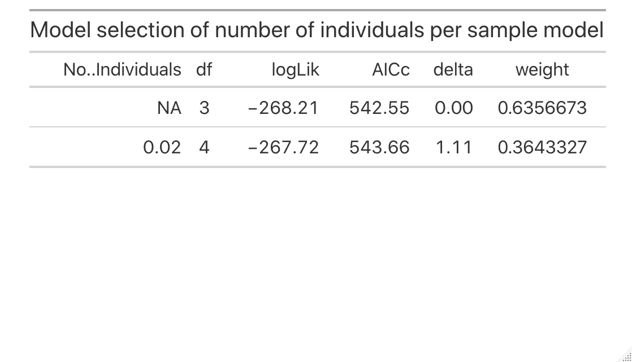

SI Table 4: Model summary examining whether samples comprising multiple individuals had more interactions than samples with only one individual. The null model (no effect of number of individuals) was the best model based on AICc values.

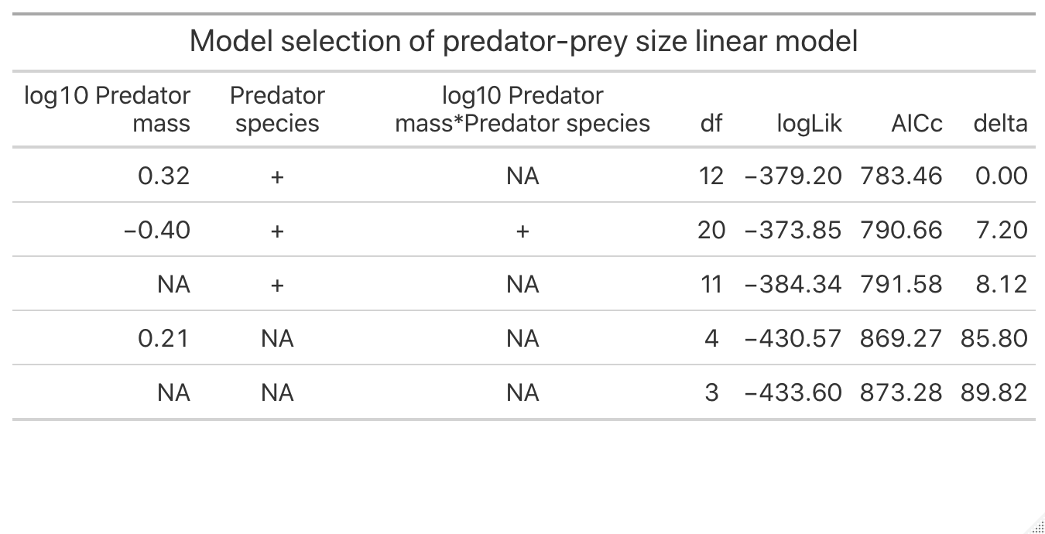

SI Table 5: Model output for linear model selection of prey size predicted by predator size and species. The best model based on AICc values included size and species, but not their interaction.

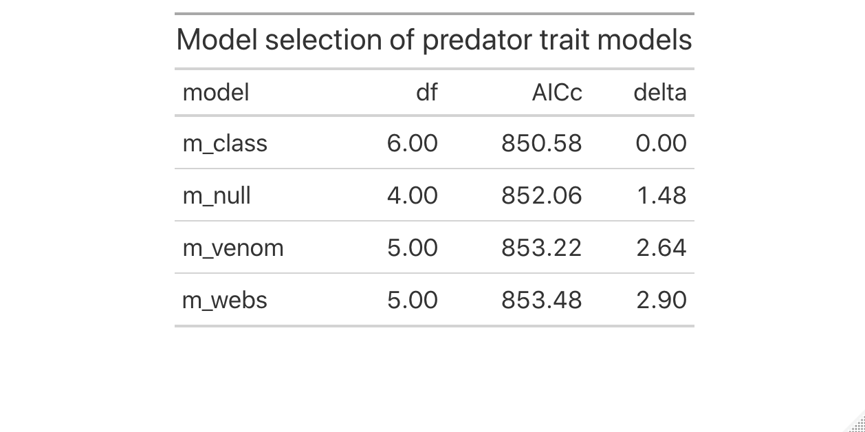

SI Table 6: Model selection of trait use and phylogeny models demonstrating that class and species identity are better predictors based on AICc values of predator:prey size ratios than predator hunting traits (venom or webs).



SI Figure 1: There was no clear statistical difference in the number of reads assigned to different diet families across sequencing runs for the 19 samples re-run across all four sequencing runs (PERMANOVA model results: run A-run B: β = 0.07, p-value = 0.82, run A-run C: β = 0.13, p-value = 0.70; run A-run D: β = 0.17, p-value = 0.48).



SI Figure 2: We compared the reads assigned using both the DADA2 and UNOISE3 algorithms. DADA2 produced more samples with high read abundances than UNOISE3 (slightly higher peak of the number of samples with high read abundances) and so we used this denoising algorithm for this study.

A:



B:



SI Figure 3: Error rates for each of the sequencing runs (A: forward reads, B: reverse reads). Based on recommendations from the developers of DADA2, we ran the DADA2 algorithm on all samples from all runs combined after verifying that the error rates were similar across runs before doing so.



SI Figure 4: Sequencing depths across all samples in our study, demonstrating the wide range in depths (10,000 – 100,000 for the current study) that can occur in DNA sequencing studies.



SI Figure 5: We chose to remove samples from analyses that had been sequenced below a certain threshold. We determined the quantiles at 0.01 increments within the dataset and found the inflection point where a 0.01 increase in the quantile led to the greatest increase in read abundance. We determined that any samples below this sequencing depth were likely sequenced at too low a level to be comparable to the other samples in our study. Through this process, this was determined to be the 0.13 quantile and a sequencing depth below 11,211. All samples with sequencing depths below this threshold were removed from further analyses.



SI Figure 6: A distribution of the number of individuals in each sample in this study. Individuals were combined for some samples to obtain ample DNA product for DNA cleaning and PCR protocols. We only combined individuals from shared species, size (± 0.5 mm), and sampling sessions. Seventy percent (n = 121/173) of samples came from individual predators, and the remaining samples comprised one or more individuals with a maximum of 12.



SI Figure 7: The number of interactions (measured as number of prey families) per number of individuals in a sample. The number of individuals in a sample did not influence over all interactions per sample.

A: B:

SI Figure 8: The number of ASVs assigned to both positive (A) and negative (B) controls. The low number of ASVs assigned per positive control suggests high assignment specificity from the DADA2 algorithm and all ASVs from positive controls matched to the fungal clonal sequence in GenBank. The low number of ASVs assigned to negative controls suggests low rates of sequence jumping. The total read number in each of these samples after denoising was: Run A: 314; Run B: 30; Run C: 22; Run D: 0.

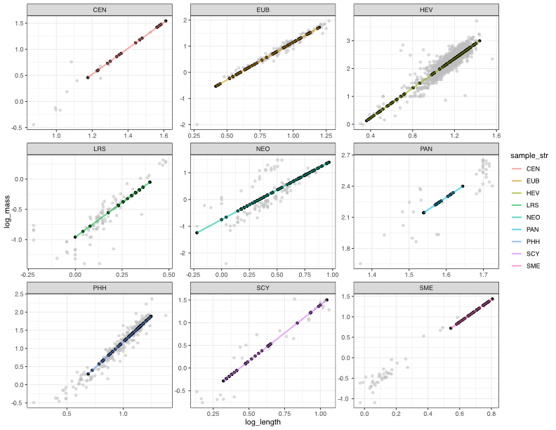

SI Figure 9: We predicted the mass of predators in this study based on mass-length relationships from predators from Palmyra Atoll and the literature. Plotted are each species’ log10-log10 mass-length relationships, with the lines and black dots indicating predicted values for predator individuals in this study and the grey background dots the distributions of those predators used to build those models. We predicted predator mass with a linear mixed effects model of predator mass predicted by predator length with a random slope and intercept of predator species by size, such that the per-species slope could vary. This model had a significant by-species length-mass relationship (β = 2.58, p-value < 0.001, R2m = 0.69 and R2c = 0.95).



SI Figure 10: The relationship between the number of species in a family and the size range of individuals measured in that family, quantified as standard error, demonstrating that beyond family-level assignments representing, on average, very few species each (1.9 ± SE 0.1 species), families that consist of more species do not have wider size ranges on average.



SI Figure 11: The body size variation of individuals measured in each family compared to the number of species in each family in the Palmyra arthropod community.